**Probabilistic Derivation for LR:**

Till now we have seen the geometrical interpretation for LR and now we will see probabilistic derivation for LR using basics of Probability and linear algebra.

As we have seen in naïve bayes that Features are real valued and assumed them to be Gaussian distributed and your class labels are Bernoulli R.V(for example coin toss).

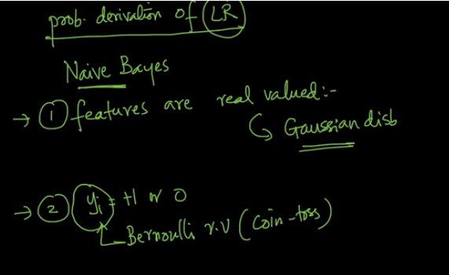

So just by making above assumption we can derive whole LR and a third assumption is all Xi and Xj are conditionally independent given Y.

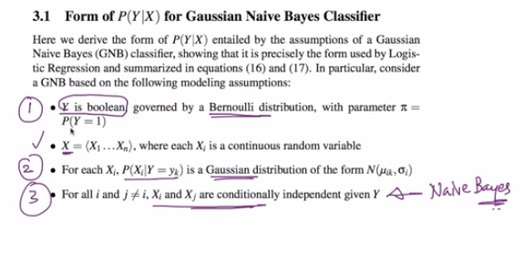

And so we can say that LR is nothing but a combination of Gaussian Normal Distribution and Bernoulli.

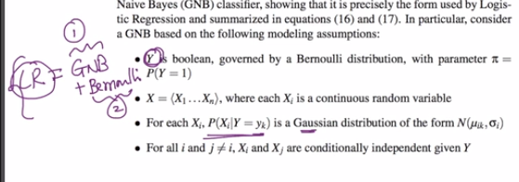’

**NOTE: if u want to see whole derivation for Probabilistic LR than go through 3.1 chapter of below given link**

Refer section 3.1 of <https://www.cs.cmu.edu/~tom/mlbook/NBayesLogReg.pdf>

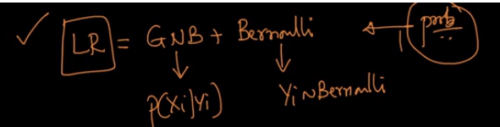

SO as we saw before also that there are two final equations for LR. One we reach when we use Geometric interpretation and another we reach when we use probabilistic approach.

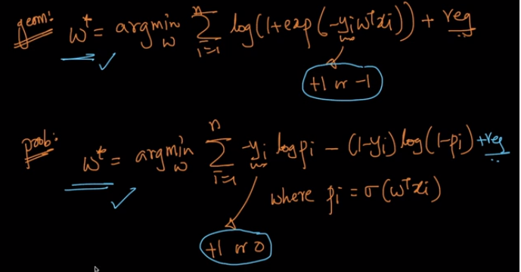

Now we will see how both the equation are actually same.

Lets take Case 1 as when Yi is +ive so in both cases i.e. geometric and probabilistic approach our Yi become +1.

As we get our Yi as +1 so whole term of probabilistic approach shown in below image becomes 0.

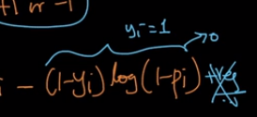

And the final output for both the approach is same.

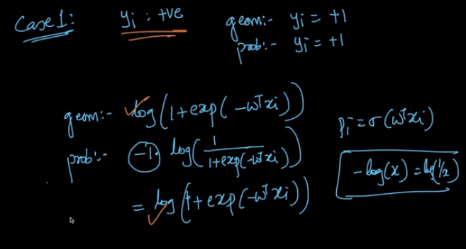

Now let’s take case 2.

Case when Yi is –ive and so Yi becomes 0.

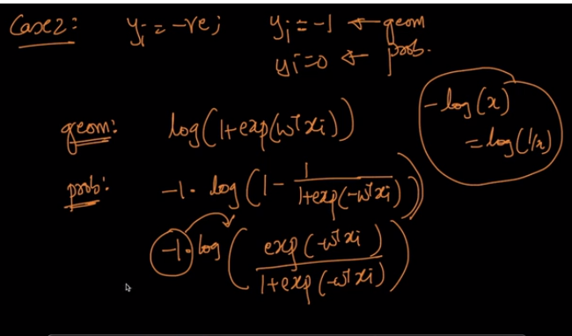

In probabilistic approach first parts became zero as we were multiplying Yi to it and Yi is 0 and we are left with as shown in above image and on making some small computation we will get both geometric and probabilistic terms as same.

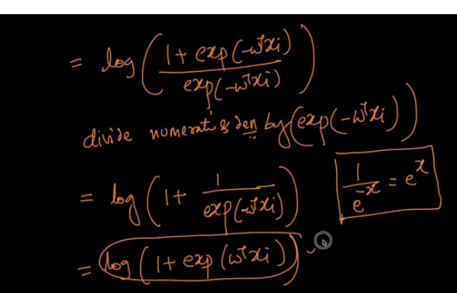

At last we got the term in probabilistic approach which is exactly same as Geometrical part.

Comments:

